Installation of JAVA

# Create Folder :

* Create Folder “JAVA” in C Drive.
* Create two subfolder under java folder named as “JDK” and “JRE”.

# Download JAVA:

* + Download JAVA jdk 1.8 or as per required version from its official website.

# Download Install:

* Run java installer file, when it ask for jdk installation location set path as JDK folder.

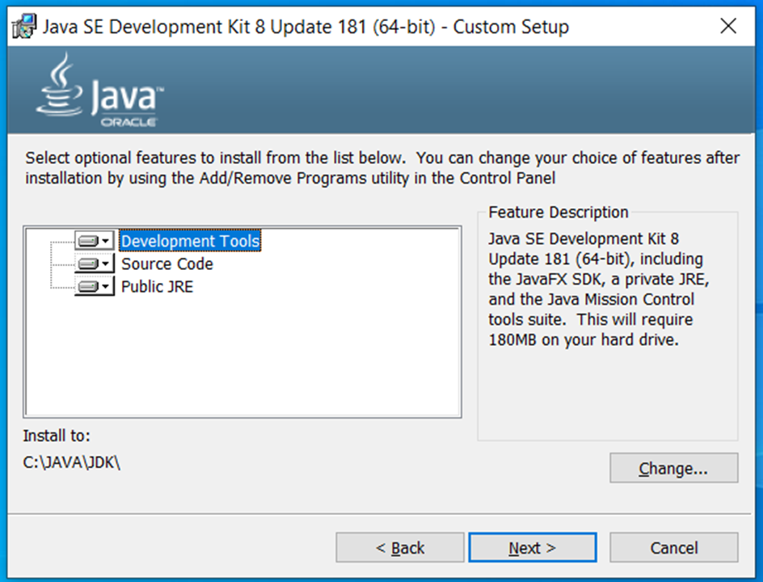

* After that when it ask for jre location choose a JRE folder for installation.

